St. Thomas More Catholic 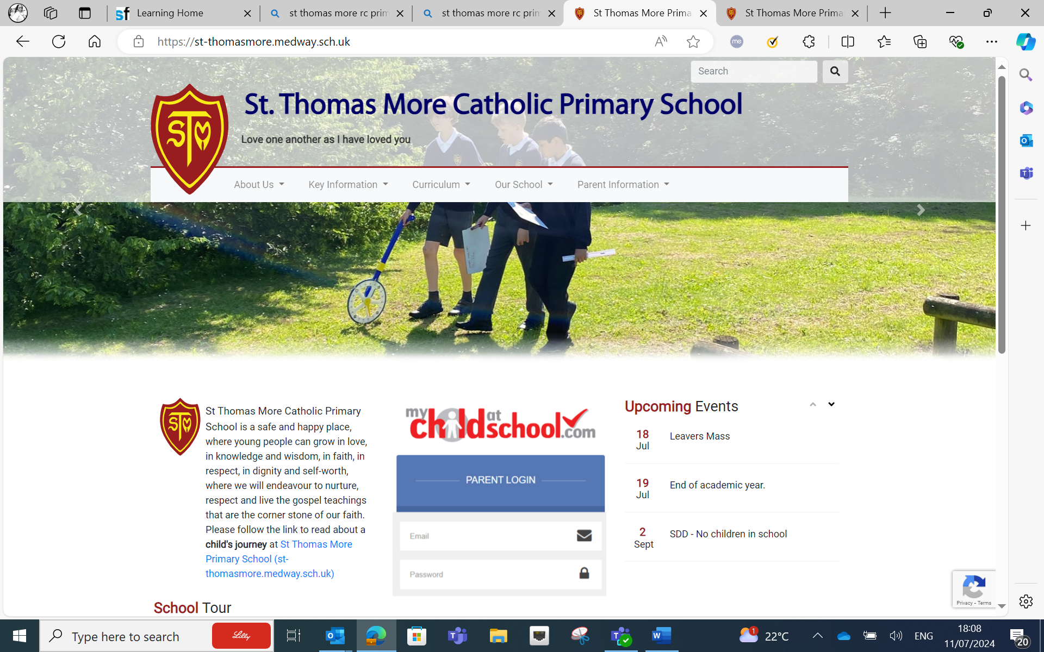 Primary School

Headteacher
Application Pack

Closing Date: Friday 13th September 2024 at 5:00pm
Shortlisting Date: Monday 16th September 2024
Interview Dates: Thursday 19th September 2024 and Friday 20th September 2024

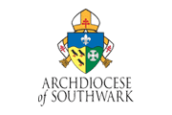

Welcome to St Thomas More Catholic Primary School.
A HEAD TEACHERS DREAM WITHIN THE ST THOMAS MORE FAMILY!!!
OUTSTANDING and highly achieved. Challenge yourself!

Dear Prospective Applicant,
Thank you for showing strong interest in our vacant position of Head Teacher.
Our most recent award was the Inclusive Schools Quality Mark with Centre of Excellence status.
St Thomas More Catholic Primary School is a Voluntary Aided school which has served the Catholic families of Waldersalde and beyond for generations. Children of the past have happily become the parents of the present, proud of their school’s strong Christian ethos and its reputation for academic excellence. As a result, we believe that our children are best placed to thrive and flourish when they feel secure in their environment and are challenged by the quality of the learning they encounter. We work consistently to ensure that these two elements remain at the core of all our endeavours.
Our heritage is unrivalled in the Medway Towns and St Thomas More Catholic Primary School is a safe and happy place. Pupils can grow and the success of the school stems from a strong pastoral base and focus, knowledge, and wisdom in faith, in respect, in dignity and self-worth, where we will endeavour to nurture, respect, and live the gospel teachings that are the corner stone of our faith.
We believe a strong parents/carer - school relationship is of the utmost importance. We provide lots of opportunities throughout each year for parents to come in to gain an experience of their child’s life in school such as ‘Bring Your Parent to . . .’ sessions, subject specific workshops, fundraising team activities, open afternoons, inviting parents in to share their cultures, lives, and workplace experiences and so much more.
I have already stated that St Thomas More Roman Catholic Primary school is a safe and happy place which has been built by strong leaders and experienced staff who work closely with parents/carers and the Governing body. Our outcomes consequently are above national averages, but our attitude is that we can always exceed. Not surprisingly professional development is a priority for school leaders focusing on research led initiatives and interventions with proven success in the classroom.
We are looking for a happy, faith-filled Catholic leader who can build from the outstanding contribution of our past Headteacher and our current Head of School, but also bring their own passion and commitment to achieving excellence in everything we do. While we want someone who will promote what is unique and best about our school, we also want someone who will bring new gifts and talents to inspire and stretch our community, providing steady leadership into the future. If you think this could be you, we would be delighted to receive your application.
St Thomas More Catholic Primary School is currently a Medway Council maintained school. We work in partnership with other schools, and this strengthens our partnerships for the future. The essence of our vibrant school community is challenging to capture in a letter, so if you are considering joining us as our new Headteacher, a visit to our school is strongly encouraged so you can see it for yourself. For an informal discussion about the role, please contact me on 0792 5326 059 or to arrange visit in the new academic year, please contact our Business Manager, Mrs Christine Fillingham in the school office on 01634 864 701 or email at: fillc002@st-thomasmore.medway.sch.uk

Yours faithfully

Simon D’Souza
Chair of Governors
Welcome to St Thomas More Catholic Primary School

School Motto:
“Love one another as I have loved you”.

School History:
The school was opened on the 10th of September 1969 with an intake of 147 children, which allowed Sister Callista, the Headmistress a theoretical quota of just over 4 teaching staff! In September 1970, the number of children increased to 210 with a staff of 6 teachers.
Visitors to the school are immediately conscious of the happy atmosphere that pervades the buildings and of the dedication with which the children are taught.

Collective Worship:
Prayer and Liturgy is an instrumental part of our school life at St Thomas More. We celebrate Masses as a school and as a Parish and we have whole school liturgies where we learn from the Gospel and classes liturgies are celebrated with our families reflecting the children’s current RE learning. Prayer and Liturgy gives us:
A sense of special time.
A sense of special place.
The intention of focusing on matters of worth ‘beyond the everyday’.
A sense of occasion.
Times of prayer and liturgy are educational, planned learning experiences and contribute to the education of the children, facilitate spiritual growth and respect of each other’s religious beliefs and their practises. This may be done by evoking the sense of beauty, awe, wonder or feelings of pride, pity, sharing or by exploring the spirituality of life and experience. Prayer and Liturgy has its own place in the curriculum, but it is also spontaneous.
The RE Coordinators take a lead in promoting collective worship and they help other children to learn the important prayers that will follow them throughout their lives. They promote collective worship and they help other children to learn the important prayers that will follow them throughout their lives.

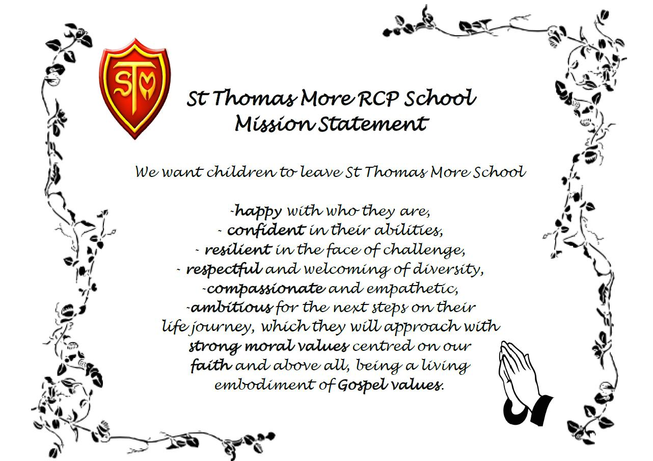

St. Thomas More Catholic Primary School

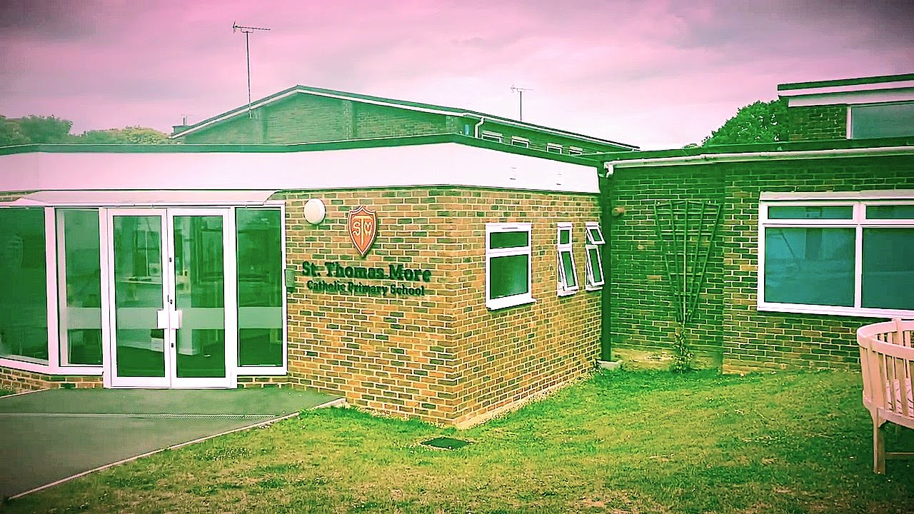

Our Family.
We often refer to ourselves as ‘The St Thomas More Family’, our school is a place of care, kindness, support and happiness for all our children and adults. We achieve excellent academic results but what is even more important to us is that every child is known as an individual and cared for in the exact way they need.
School size/Age range.
St Thomas More Catholic pupils age between Reception classes from the ages of 4 years old and Year 6 classes up to the age of 11 years old. We currently have 420 pupils attending our school.
School demographic.
This location falls within the parliamentary constituency of Chatham and Aylesford Co, represented by the Labour MP, Tris Osbourne. At the last general election Conservative won control with a majority of 18,540 votes over Labour. A breakdown of voting at the last election is shown above.
Extra-curricular offer.
Though each of our terms, we offer the pupils from Year 1 to Year 6 an opportunity to grow sociably and mentality in a wide range of activities that help nurture and develop their well well-being. They include, Dancing, Football, Basketball, Rounds, Netball, Table Tennis, Cricket to name a few. Our school also helps pupils with team building classes and they can be part of the Chaplaincy Team, Cultural Capital team, Digital Leaders, Eco warriors and our Forest School Team.

Number and breakdown of staff.
Senior Team Leaders – 4
(inc 1 Exec Head Teacher currently until a new Head Teacher is appointed)

Teaching & Curriculum Team – 18
(14 teachers in class, Opal teacher, 3 x teachers covering curriculum)

Learning Support Staff – 19

Administration & Support Team – 17
(3 office, Pastoral Manager, SEN admin, caretaker, 2 x cleaners, 6 x MMS, 3 x breakfast/afterschool club)

Other support staff including admin, premises, mid-day meal supervisors, breakfast and afterschool club – 12

Support offered to staff.
We ensure the effective management and deployment of teaching and support staff together with appropriate systems of delegation and discipline through the management structure of the School.
School website.
A child’s journey starts at St Thomas More Catholic School. Please see below our website for the start of your journey…
https://st-thomasmore.medway.sch.uk/
Parish Links.
Our school has strong links with our parish church, St. Simon Stock Parish, Walderslade, which enhances the spiritual and moral development of the community we serve with the guidance of our Parish Priest, Father Pawel.
https://stsimonwalderslade.co.uk/

Our Location

School Name – St Thomas More Catholic Primary School
School Full Address – Bleakwood Road, Walderslade, Chatham, Kent, ME5 ONF
Telephone Number – 01634 864701
Email Address - office@st-thomasmore.medway.sch.uk
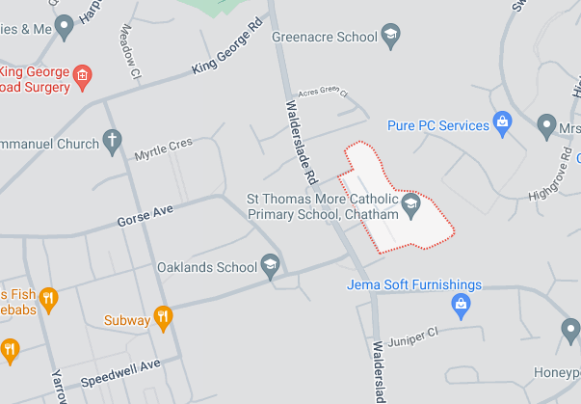

- Main Road Links - Bleakwood Road comes off Walderslade Road in Chatham and is in the Southeast region. The postcode is within the Wayfield & Weeds Wood area which is in the constituency of Chatham and Aylesford.
- Train/bus links – Chatham Train station is 2.6 miles and Chatham Bus Station (bus176 and 184) is 2.9 miles.

Job Description

Job Title: Head Teacher in a full-time position.
As a leader of a Catholic school community, a Headteacher:

The Head Teacher will promote and support the vision and direction of the school, providing day-to-day leadership that be responsible for leading Catholic education based on Gospel Values, will enable the school to build success and provide the highest quality education for the best interests of the school’s pupils. The Head Teacher leads and manages the school on a day-to-day basis and is the first point of contact for all stakeholders and external agencies in matters relating to the school.
- Working with Governors to create the strategic vision for the school in the partnership and promote the vision of Catholic education, values and ethos to pupils, staff, Governors, parents, parish, and the wider community.
- Motivate others to create a shared learning culture and positive climate through distribution of leadership through teams and individuals in the school.

- Develop a shared expectation of outstanding teaching and learning, with opportunities for shared learning and Continued Professional Development. (CPD)

- Monitor progress against targets for pupil achievement and make suggestions to improve teaching and learning practices accordingly.

- Set high educational standards – ensure staff understand this expectation and that effective support measures are in place to help staff achieve this aim. Uphold their duty to give account and accept responsibility.
- Monitor school leaders’ performance and conduct reviews of performance – offer support and training as appropriate. Set high expectations and challenging targets for the school.

- Create an inspiring, professional work environment consistent with the school’s values and aspirations.

- Be responsive to the needs of pupils, listen to pupil voice surveys and suggest adjustments to improve teaching strategies accordingly. Create a curriculum that is child centred and inspiring so that high standards in attainment and achievement are reached and maintained.
- Know, understand and act within the statutory frameworks which set out their professional duties and responsibilities. Articulate the school’s vision as a provider of Catholic education to key stakeholders within the partnership and ensure the vision is regularly reviewed.

Section 1: Ethics and Professional Conduct.
Catholic Headteachers are expected to demonstrate consistently high standards of principled and professional conduct, inspired by Christ and demonstrate the qualities of character, fundamental to the Catholic tradition: faith, hope, love, justice, solidarity temperance, fortitude and practical wisdom. A Catholic Headteacher is expected to meet the teachers’ standards and be responsible for providing the conditions in which teachers can fulfil them.
In addition, a Catholic headteacher upholds and demonstrated the Seven Principles of Public Life, at all times. Known as the Nolan principles, these form the basis of the ethical standards expected of public office holders:

- Selflessness
- Integrity
- Objectivity
- Accountability
- Openness
- Honesty
- Leadership

A Catholic Headteacher is the custodian of a Catholic school and as such embodies the abundant hope of the Church has placed in education. A Catholic Headteacher is entrusted with the task of human formation in conformity with Christ and Church teaching, maintaining high standards of ethics and behaviour, both within and outside school.

A Catholic Headteacher:
- Builds relationships of mutual respect, rooted in the belief that all are made in the image and likeness of God and observe proper boundaries appropriate to their professional position.
- Will show tolerance and respect for the rights of others, recognising differences and respecting cultural diversity within contemporary society, enabling each person to play their full part in building and sustaining the Common Good.
- Will uphold British values, including democracy, rule of law, individual liberty and mutual respect, tolerance of those of different faiths and beliefs understanding that such values are rooted in the Catholic understanding of dialogue and Catholic Social Teaching.

Section 2: Headteacher Standards.
School Culture:
- To establish and sustain a Christ centred vision embodied in the school’s Catholic mission, ethos and strategic direction in partnership with the parish and Trust (If appropriate), governors, the school community and Archdiocese.
- To create a Christ inspired culture where pupils experience a positive and enriching school life, enabling them to flourish.
- To uphold aspirational educational standards, which reflect the distinctive nature of Catholic education and which prepares pupils from all backgrounds for their future.
- To ensure a culture of professionalism based on mutual respect and the pursuit of excellence.
Teaching:
- To establish and sustain high quality teaching, across all subjects and phases, built on evidence and research based understanding.
- To ensure teaching is underpinned by high levels of subject expertise and approaches which respect the distinct nature of the subject or specialism and demonstrates how each subject and discipline, contributing to the Christian vision of human flourishing.
Curriculum and Assessment:
- To ensure a broad, structured and coherent curriculum entitlement, grounded in the distinctive characteristics of Catholic education which clearly sets out the knowledge, skills and values that will be taught.
- To establish and develop effective curricular leadership, developing the expertise of subject leaders, providing access to range of networks and communities.
- To ensure valid, reliable and accurate approaches are used when assessing pupils’ knowledge and understanding of the curriculum.
Behaviour:
- To develop and establish high expectations of behaviour, based on love, justice and reconciliation, built upon relationships and rules that are understood by all.
- To ensure high standards of behaviour through the promotion of the school’s values, ethos and mission, in accordance with the school’s behaviour policy.
- To adopt a consistent approach to the application of behaviour management.
SEND:
- To ensure the school holds ambitious expectations for all pupils with additional and special educational needs and disabilities in light of the principles of Catholic Social Teaching.
- To ensure the school works effectively in partnership with parents, carers, parish and professionals, to identify the needs of SEND children, providing support and adaptation where required.
- To ensure that the school fulfils its statutory duties with regards to the SEND code of practice.

Professional Development:
- To ensure that staff are provided with high quality CPD, in all areas of practice and that is aligned to the school development areas.
- To make sure that all CPD is strategically planned, sequenced and evaluated. That is consistent with the approaches laid out in the standards for teachers’ professional development
- To draw on experts to provide high quality CPD, including diocesan and nationally recognised career and professional frameworks and programmes.
- To ensure the building of capacity and to support succession planning.
Organisation and Management:
- To have an effective approach to safeguarding, to ensure the protection and safety of both staff and pupils.
- To allocate and prioritise financial resources, ensuring efficiency, probity and effectiveness. The use of public funds should reflect the school’s Catholic mission.
- To ensure a good work/life balance for staff, through effective management and deployment.
- To develop and oversee systems, processes and policies that enable the school to operate effectively, where there is a clear understanding of the Church’s mission in education.
- To have a robust approach in identifying, managing and mitigating any risks
Continuous School Improvement:
- To identify, evaluate and analyse any persistent problems and barriers which limit the effectiveness of the school, identifying key areas for improvement.
- To develop evidenced based and well-targeted plans that are both timely and realistic and which are suited to the school’s Catholic context.
- To ensure careful and effective implementation of improvement strategies, which lead to improvement over time.
Working in Partnership:
- To develop strong relationships with the wider community, working in partnership with parents, carers, the parish, diocese and the local community.
- To develop the network of Catholic schools, other schools and organisations, in a spirit of challenge and support.
- To develop relationships with other professionals in a range of public services, to improve the educational outcome for all pupils.

Governance and Accountability:
- To embrace the contribution of effective governance, rooted in strategic stewardship of Catholic mission in education, upholding the obligation to give account and accept responsibility.
- To develop and nurture a professional and appropriate relationship with governors which is inspired by a Christ centred vision for human formation.
- To ensure that staff are clear on their professional responsibilities and that they are held to account.
- To ensure that the school operates within the required regulatory frameworks and meets all of its statutory duties.

Based on the 2020 DfE Headteachers’ Standards. These have been amended to reflect the distinctive nature of Catholic leadership and the role of a Catholic leader in upholding the mission of the Church.

Person Specification
Introduction
- St Thomas More is an 'Outstanding' Catholic Primary School. The School serves the parish of St Simon’s Stock Church. We are very proud that St Thomas More has established a reputation for high standards and high achievement. Our aim is not simply to provide an outstanding academic education, but to develop in our pupils an understanding of, and respect for, spiritual and moral values within a caring Christian community.
- The core purpose of the Headteacher in a Catholic school is to provide leadership in the context of a community rooted in the Christian faith. Thus it is an essential requirement the person appointed to the post at St Thomas More Catholic Primary School has a strong, personal faith and recognises the opportunities and challenges facing our school as a vibrant part of the mission of the Church in education.
- The Governing Board is seeking to appoint a highly effective, dynamic and inspirational Catholic leader with a passion for inclusive community building to lead St Thomas More Catholic School on its improvement journey. The successful applicant will be a practising Catholic who can demonstrate how this can be achieved by making the school’s Values, Aims and Purpose a reality for all the pupils, staff and the wider community.
- The successful candidate will have strong leadership skills, a deep understanding of educational best practices and a commitment to fostering a positive and inclusive learning environment for all pupils and staff. If you are ready to take on this rewarding and influential role, we encourage you to apply and be part of our family.
- You will witness the dedication and commitment of our staff in providing the highest quality education to our pupils. Together, we have achieved numerous successes, and we are proud of the positive impact we have made on the lives of our children and families. The position of Headteacher at St Thomas More offers a unique opportunity to lead an exceptional team of educators, support staff, and pupils in achieving academic excellence and fostering a nurturing learning environment. We are confident that with the right leadership, St Thomas More will continue to thrive and maintain its reputation for excellence in education.
- We encourage qualified candidates with a passion for education, strong leadership skills, and a commitment to fostering a culture of inclusivity and academic excellence to apply for the position. The successful candidate will have the opportunity to build upon the foundation has been laid and lead St Thomas More into its next chapter of continued success.
A practising Catholic is someone who has been sacramentally initiated into the Catholic Church and who adheres to those substantive life choices which do not impair them from receiving the sacraments of the Church and which will not be in any way detrimental or prejudicial to the religious ethos and character of the school. Inspired by the Gospel and sustained by God’s grace, a ‘practising Catholic ’will give sincere external expression to their interior faith through specific religious, moral and ethical behaviour which is in accordance with the teaching of Christ and the Catholic Church.

Person Specification
Qualities and Knowledge | Essential or Desirable | Evidence
A practising Catholic, evidenced by a priest reference | E | I/R
Qualified Teacher Status | E | A
Degree | E | A
NPQH or similar | D | A
CCRS | D | A
Teaching and leadership experience in one or more Catholic primary/secondary schools | D | A/I/R
Lead by example and be a positive role model with excellent communication skills | E | I/R
Ability to articulate a clear vision and purpose for Catholic education and to share their Catholic faith with a range of colleagues who may or may not be Catholic | E | A/I/R
Personal impact and presence | E | I/R
Participation in a parish community | E | A/I/R
Ability to lead the spiritual development Of staff and pupils | E | I/R
Understand the current educational provision and the wider school systems | E | A/I
Political and financial astuteness | E | A/I/R
Demonstrate and experience of working alongside clergy and faith leaders. | E | A/I/R
Pupils and Staff | Essential or Desirable | Evidence
Have ambitious standards and high expectations for all pupils | E | A/I/R
Excellent understanding of high quality teaching and learning | E | A/I/R
Promote the development of the whole child | E | A/I/R
Use data analysis to effectively drive whole school improvement | E | A/I/R
Encourage staff and pupils to develop their unique potential, character | E | A/I/R
Identify emerging talent, develop excellence and clear succession planning | E | A/I/R
Systems and Process | Essential or Desirable | Evidence
Effective strategic leadership and astute and understanding of school finance | E | A/I/R
Ensure the safety of all staff and pupils, at all times | E | A/I/R
Promote excellent behaviour and positive attitudes to school life | E | A/I/R
Systems for appraisals to hold all staff to account | E | A/I/R
Skills to challenge underperformance | E | A/I/R
Understanding the importance of strong governance to hold the school to account | E | A/I/R
Ensure value for money in deploying resources and budgets, for the best outcomes for all | E | A/I/R
Promote distributive leadership throughout the school | E | A/I/R
School Improvement | Essential or Desirable | Evidence
Knowledge and experience of working with other schools and organisation | E | A/I/R
Develop effective partnerships with other professionals | E | A/I/R
Use evidence based research to achieve excellence | D | A/I/R
Provide opportunities for high quality staff development | E | A/I/R
A confident and innovative approach to school improvement | E | A/I/R
Provide inspiration and encouragement for all members of the community | E | A/I/R
Child Protection | Essential or Desirable | Evidence
Ensure all CP policies and procedures adopted by governors are fully implemented and adhered to by staff | E | A/I/R
Ensure that sufficient resources and time are allocated to enable staff to perform their CP related responsibilities effectively | E | A/I/R
Securing Accountability | Essential or Desirable | Evidence
Fulfil all commitments arising from contractual accountability to the governing body | E | A/I/R
Ensure individual staff accountabilities are clear, understood, agreed, reviewed and evaluated | E | A/I/R
Work with the governing body to enable it to meet its statutory responsibilities | E | A/I/R
Develop an accurate and understandable account of the school’s performance for a range of stakeholders | E | A/I/R
Personally contribute to school achievement, taking account of feedback from others | E | A/I/R
Strengthening the Community | Essential or Desirable | Evidence
Build a culture and curriculum which takes account of the richness and diversity of the community’s Catholic faith | E | A/I/R
Create and promote strategies for challenging racial and other prejudices | E | A/I/R
Ensure that learning experiences are enriching and are linked into and integrated with the wider community | E | A/I/R
Collaborate with agencies in providing for the academic, spiritual, moral, social, emotional and cultural wellbeing of all | E | A/I/R
Develop and maintain an effective partnership with parents and carers | E | A/I/R
Share effective practice, working in partnership with other schools | E | A/I/R
Application Form and Letter | Essential or Desirable | Evidence
The appropriate form to be completed in full and legible | E | A
Supporting statement to be clear, concise and related to the post being applied for and appointment criteria (No more than 2 sides of A4 in font size 11) | E | L
Confidential References and Reports | Essential or Desirable | Evidence
A positive and supportive written faith reference from a priest where the applicant regularly worships | E | R
A positive recommendation from current employer or Headteacher | E | R
A second professional reference | E | R

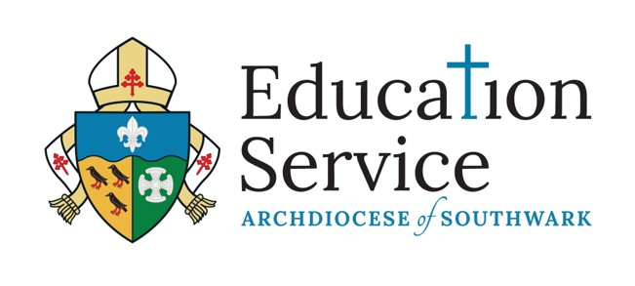
Working in the Archdiocese of Southwark

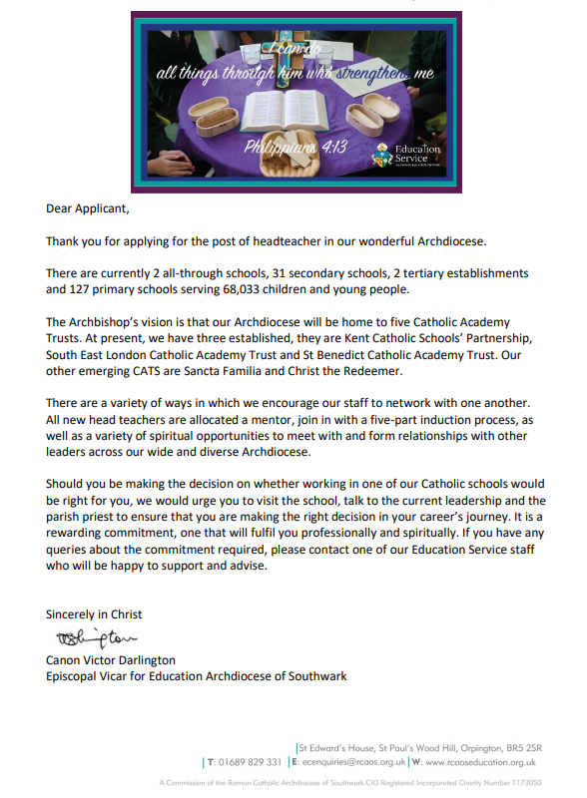

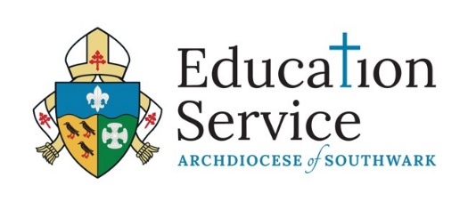
Headteacher Wellbeing Offer:
Our offer is available to any serving Headteacher in the diocese and is provided by the Education Service
The service is:
- Designed and structured to meet the needs of Headteachers in the Archdiocese
- A confidential provision for Headteachers in all phases
- An opportunity to talk confidentially on a personal and professional basis
- Created to facilitate and nurture links with other Headteachers and professionals
The Aims of the Service:
The service:
- Promotes the wellbeing of Headteachers in the Archdiocese
- Provides support for individual Headteachers
- Assists the Headteacher in the resolution of issues
- Enables the development of networks
- Supports the development of networks and relationships between Headteachers, Governors and diocesan and local authority personnel
The role of the Archdiocese:
- The Archdiocese is committed to supporting Headteachers in their role and to working in partnership with it trusts and schools
- The Education Service acts as the agent in the employment of a coordinator for Headteacher wellbeing

